Data Analytics using Python

Week 12 Question Bank Answer
1 | What is CART?
Ans.1) | CART (Classification and Regression Trees) is a decision tree algorithm used for both classification and regression problems. It is a popular machine learning algorithm used for building decision trees based on the values of features in a dataset. The algorithm splits the data based on the feature that provides the best split, according to a certain criterion such as information gain or Gini impurity.  CART creates binary trees, where each internal node represents a feature, each branch represents a decision rule, and each leaf node represents a class label or a continuous value. The algorithm uses a greedy approach to find the best split at each node, without considering the future splits.  CART can handle both categorical and numerical data, making it a versatile algorithm for various types of data analysis tasks. It can also handle missing values by using surrogate splits, which are alternative splits that can be used when the primary split is not applicable due to missing values.  CART has several advantages, such as its simplicity, interpretability, and ability to handle both types of data. However, it can also suffer from overfitting, where the tree becomes too complex and captures the noise in the data. To prevent overfitting, CART uses techniques such as pruning, where the tree is reduced to a smaller size by removing the less important nodes.  In summary, CART is a powerful decision tree algorithm that can be used for both classification and regression problems. It is simple, interpretable, and versatile, but it requires careful tuning to prevent overfitting and ensure good performance.

2 | Write decision tree algorithm.
Ans.2) | To write a decision tree algorithm, you can follow a basic structure that involves recursively splitting the data based on features to create a tree structure. Here is a simple pseudocode for a decision tree algorithm:  ```python  # Decision Tree Algorithm  class Node:  def __init__(self, feature=None, threshold=None, left=None, right=None, value=None):  self.feature = feature # Feature to split on  self.threshold = threshold # Threshold value for the split  self.left = left # Left child node  self.right = right # Right child node  self.value = value # Value if the node is a leaf  def decision_tree_algorithm(data):  # Check termination conditions  if stopping_condition(data):  return Node(value=calculate_leaf_value(data))  # Find the best split  feature, threshold = find_best_split(data)  # Split the data  data_left, data_right = split_data(data, feature, threshold)  # Recursively build the tree  left_node = decision_tree_algorithm(data_left)  right_node = decision_tree_algorithm(data_right)  return Node(feature=feature, threshold=threshold, left=left_node, right=right_node)  ```  This pseudocode outlines the basic structure of a decision tree algorithm. It involves defining a Node class to represent the nodes in the decision tree and a recursive function `decision_tree_algorithm` to build the tree by finding the best splits at each node based on the data. The algorithm recursively splits the data until a stopping condition is met, such as reaching a maximum depth or minimum number of samples in a node.  You can further enhance this algorithm by incorporating splitting criteria like Gini impurity or information gain, handling categorical variables, pruning the tree to prevent overfitting, and optimizing the splitting process for efficiency.

3 | What are different attribute selection measures in decision tree?
Ans.3) | Decision tree attribute selection measures are used to determine the best attribute to split the data at each node in the tree. The three most popular attribute selection measures are information gain, gain ratio, and Gini index.  Information gain is a measure of the difference in entropy before and after the split. It is calculated as the difference between the entropy of the parent node and the weighted average of the entropy of the child nodes. The attribute with the highest information gain is selected as the splitting attribute.  Gain ratio is a modification of information gain that takes into account the number of categories of the attribute. It is calculated as the ratio of information gain to the intrinsic information of the attribute. The attribute with the highest gain ratio is selected as the splitting attribute.  Gini index is a measure of the impurity of the data. It is calculated as the sum of the squared probabilities of each category. The attribute with the lowest Gini index is selected as the splitting attribute.  These measures are used to build decision trees that are accurate and easy to interpret. The choice of measure depends on the nature of the data and the problem at hand.

4 | How does tree pruning work in decision tree?
Ans.4) | Tree pruning is a technique used in decision trees to reduce the size of the tree and prevent overfitting. It involves removing some of the branches of the tree that are based on noise or outliers in the training data.  There are two common approaches to tree pruning: pre-pruning and post-pruning.  In pre-pruning, the tree is pruned by halting its construction early. This can be done by assessing the goodness of a split using statistical measures such as statistical significance, information gain, or Gini index. If the split is not good enough, the algorithm stops splitting at that node.  In post-pruning, the tree is fully grown first, and then subtrees are removed from it. A subtree at a given node is pruned by replacing it with a leaf node that is labeled with the most frequent class among the subtree being replaced.  Pruned trees tend to be smaller and less complex than unpruned trees, making them easier to comprehend and faster at correctly classifying independent test data. However, they may have higher error rates than shallow trees with many leaves.  Several comparative studies have found that no one attribute selection measure has been found to be significantly superior to others, and that measures that tend to produce shallower trees may be preferred.

5 | 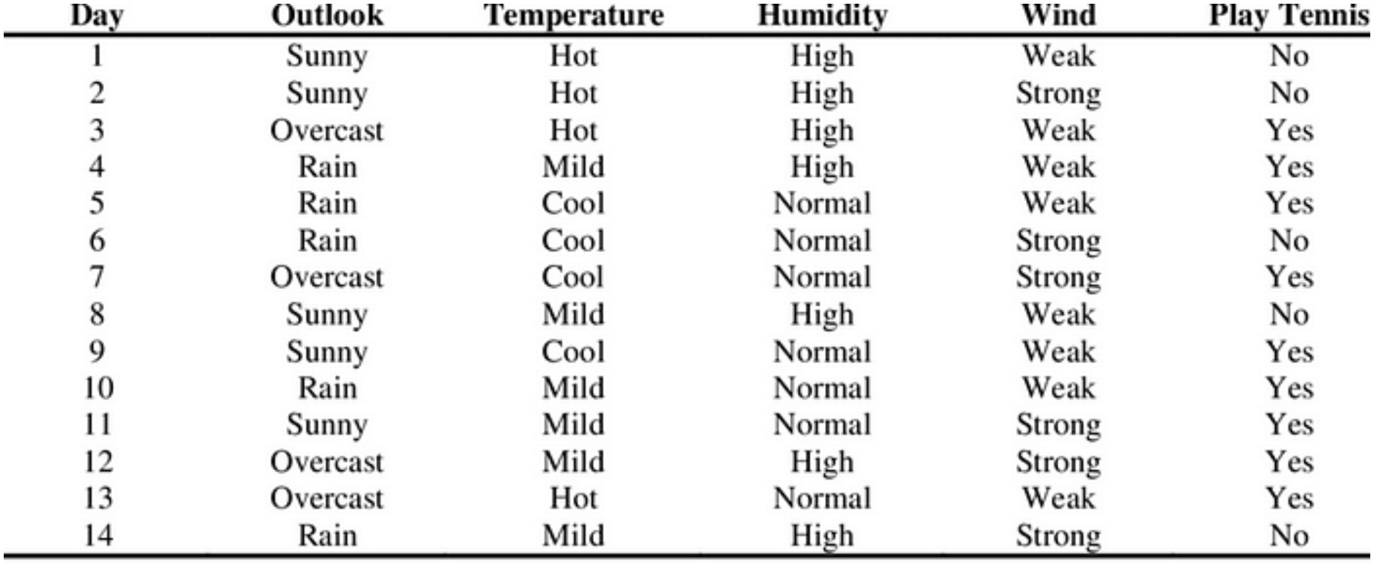  Calculate entropy for the following data and find out the root node of decision tree using information gain.
Ans.5) | To calculate the entropy for the given data, we first need to determine the probability of each class label (play tennis) in the data. There are two class labels, "Yes" and "No", and the total number of tuples is 14.  The probability of "Yes" is 9/14 and the probability of "No" is 5/14.The entropy of the data can be calculated as:  Entropy(D) = - (9/14) log2(9/14) - (5/14) log2(5/14) = 0.94  To find the root node of the decision tree using information gain, we need to calculate the information gain for each attribute (Outlook, Temperature, Humidity, and Wind) and select the attribute with the highest information gain as the root node.  The information gain for an attribute can be calculated as:  Information Gain(A) = Entropy(D) - ∑(size(Sj)/size(D)) Entropy(Sj)  where Sj is the subset of the data for which the attribute A has the value j, and the sum is over all possible values of A.  Calculating the information gain for each attribute, we get:  - Information Gain(Outlook) = 0.246  - Information Gain(Temperature) = 0.029  - Information Gain(Humidity) = 0.151  - Information Gain(Wind) = 0.048  Therefore, the root node of the decision tree should be "Outlook" with an information gain of 0.246.

6 | What are different measures for attribute selection in decision tree?
Ans.6) | The different measures for attribute selection in decision trees are Information Gain, Gain Ratio, and Gini Index.  - Information Gain: Information gain measures the value or "information content" of messages. The attribute with the highest information gain is chosen as the splitting attribute for a node. It minimizes the information needed to classify the tuples in resulting partitions and reflects the least randomness or "impurity" in these partitions.  - Gain Ratio: Gain ratio is an extension to information gain that overcomes the bias of information gain towards attributes with a large number of values. It applies normalization to information gain using a "split information" value, representing the potential information generated by splitting the training dataset into partitions. The attribute with the maximum gain ratio is selected as the splitting attribute.  - Gini Index: The Gini index measures the impurity of a data partition or set of training tuples. It considers a binary split for each attribute and computes a weighted sum of the impurity of each resulting partition. The attribute that maximizes the reduction in impurity (or has the minimum Gini index) is selected as the splitting attribute.  These measures play a crucial role in determining how the tuples at a given node are split in a decision tree, leading to the creation of an optimal tree structure for classification or regression tasks.

7 | How does gain ratio differs from information gain?
Ans.7) | Gain ratio differs from information gain in decision trees in the following ways:  - Normalization: Gain ratio applies normalization to information gain using a "split information" value, which represents the potential information generated by splitting the training dataset into partitions based on the attribute being considered. This normalization helps overcome the bias of information gain towards attributes with a large number of values.  - Calculation: Information gain measures the information acquired based on the same partitioning, focusing on the information with respect to classification. On the other hand, gain ratio is defined as the ratio of information gain to the split information, which accounts for the potential information generated by splitting the dataset into different partitions.  - Selection Criteria: In decision tree attribute selection, the attribute with the maximum gain ratio is chosen as the splitting attribute, unlike information gain where the attribute with the highest information gain is selected. Gain ratio considers both the information gain and the split information, providing a more balanced approach to attribute selection.  Therefore, gain ratio in decision trees offers a more refined approach to attribute selection by considering the information gain in relation to the potential information generated by splitting the dataset, leading to a more robust selection of splitting attributes.

